**BHAVAN’S B.P. BAL MANDIR, KORADI, NAGPUR.**

**SESSION: 2024-2025**

**REPORT ON MULTI CULTURE FANCY DRESS COMPETITION**

**This year Bhavan’s B. P. Vidya Mandir, Koradi, Nagpur has undertaken a yearlong International Project “RIDS” i.e. Recognition of International Dimensions in School, which includes seven different projects which are embedded within the school curriculum. Out of which the project undertaken for Bal Mandir is on the topic “CULTURAL KALIEDOSCOPE”** pertaining to the Traditional Dance forms, cuisines and clothing style of India (Maharashtra), Japan, Bhutan, Nepal & Russia.

**Recently, the school conducted** a “Multi-Culture Fancy Dress Competition” under this project wherein the parent and the child came decked up as per the **CLOTHING STYLE** of the country allotted to them and also shared information about the same. Parent-child representing India (Maharashtra) captivated the audience with their regal Nawari sarees , the Japanese parent-child duo brought a serene charm with their intricately designed Kimonos while the Bhutan pair impressed with their vibrant Gho *and* Kira. Russian participant duo embraced the grace of their traditional Sarafan and the Ponev. The activity was judged by the school EPTA members Smt. Kanika Jani, Smt. Komal Goel and Smt. Reema Khan.

Mast. Shinoy Khatarkar along with the mother Smt. Kirti Khatarkar were selected as the best parent-child duo for the excellent presentation of Japanese traditional attire.

The parent-child duo was a spectacle of tradition and creativity as they walked hand-in-hand creating moments of pure joy and leaving the audience with lasting memories. Their smiles, confidence, and togetherness lit up the event and inspired all present.

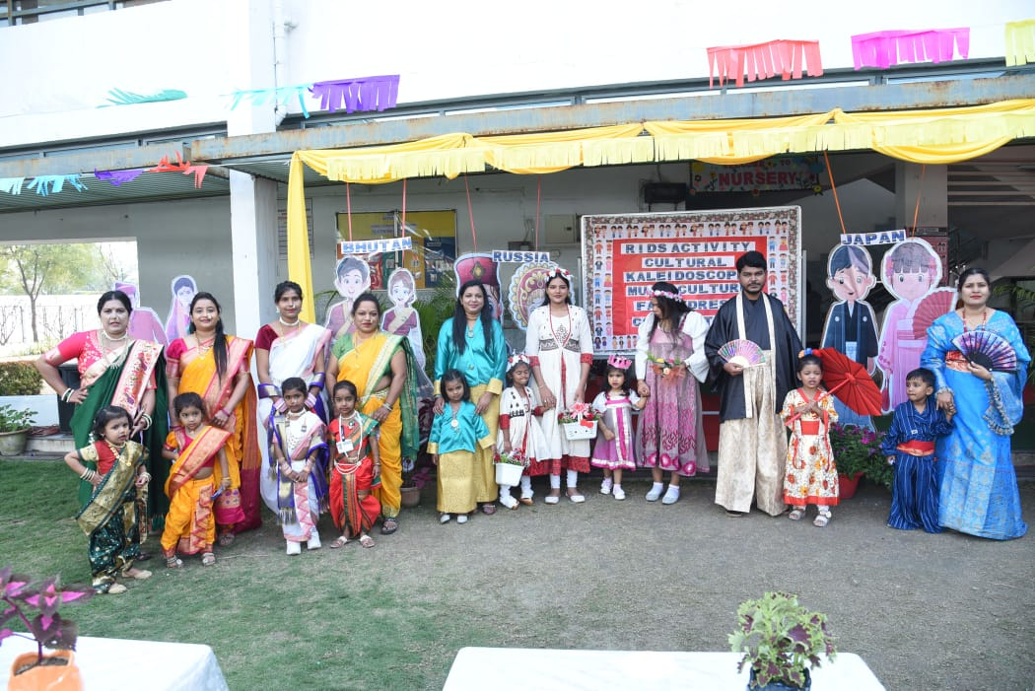 The activity was a resounding success under the able guidance of the Principal Ms. Sarbani Bose, Pre-Primary I/C Ms. Neha Khatri and the pedagogues whose unfaltering efforts paved way for the smooth culmination of the event.

***Parent- child duo donned in Traditional attire of different countries.***